**Project Design Phase- I**

|  |  |
| --- | --- |
| Date | 1 October 2022 |
| Team Id | PNT2022TMID06168 |
| Project Name | Crude Oil Price Prediction |
| Maximum Marks | 4 Marks |

Solution Architecture:

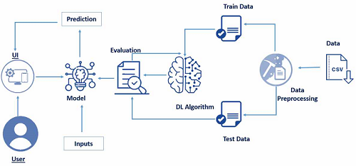  **Chatbot**